# CBHS Analyst Programmer Exam

## Architecture:

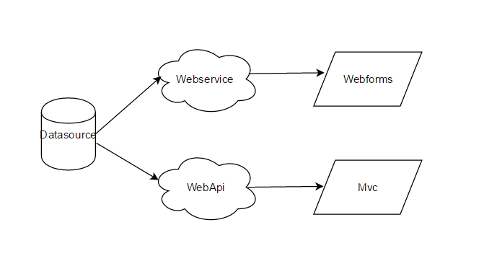

## Solution Projects:

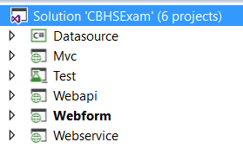

1. Datasource – in memory data source for the services (Webservice and Webapi). AddMember and GetMembers methods are provided.
2. Webapi – REST service to be consumed by the Mvc application
3. Webservice – SOAP service to be consumed by the Webform application
4. Webform – an ASP.NET webform application that consumes SOAP service
5. Mvc – a ASP.NET application that consumes REST service.
6. Test – a Microsoft unit testing framework that contains test classes for all projects.

## Objective:

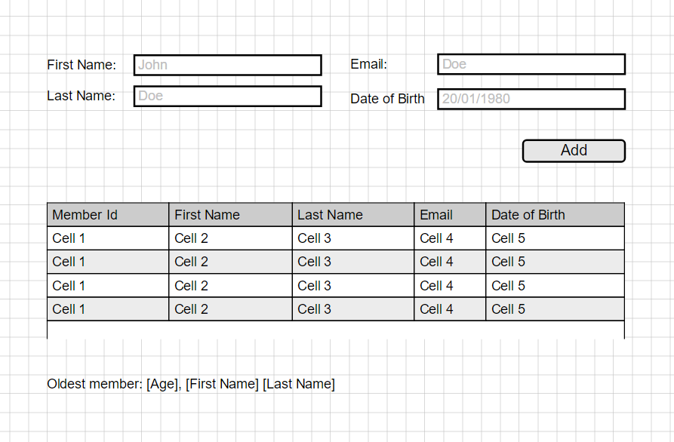

1. Based on the mock-up above, create a one pager (1 webform and 1 mvc) that:
   1. Displays added members in tabular view
   2. Displays the oldest member’s information.

## Rules:

1. Webform, Webservice and MVC, WebAPI are required. Do not submit incomplete solutions.
2. All codes must be on an enterprise level (refactored). Unit tests and IOC (DI preferred) are required.
3. Styles and design must be simple but responsive.
4. Feel free to add 3rd party references but briefly explain the purpose (put comments on the code).